***SQL QUERIES***

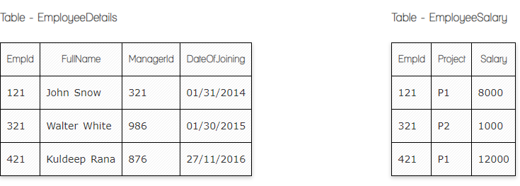

***1.Write a query to fetch employee names and salary records. Return employee details even if the salary record is not present for the employee.***

Select FullName, EmployeeSalary

From EmployeeDetails

Left Join EmployeeSalary

On EmployeeSalary.EmpId = EmployeeDetails.EmpId

***2. Write a SQL query to right join both tables and draw the results.***

Select FullName, Employeesalary .EmpId, Employeesalary.Salary

From Employeesalary

Right Join EmployeeDetails

On EmployeeDetails.EmpId= EmployeeSalary.EmpId;

|  |  |  |  |  |  |
| --- | --- | --- | --- | --- | --- |
| **EmpId** | **Project** | **Salary** | **FullName** | **ManagerID** | **DateOfJoining** |
| 121 | P1 | 8000 | John Snow | 321 | 01/31/2014 |
| 321 | P2 | 1000 | Walter White | 986 | 01/30/2015 |
| 421 | P1 | 12000 | Kuldeep Rana | 876 | 27/11/2016 |

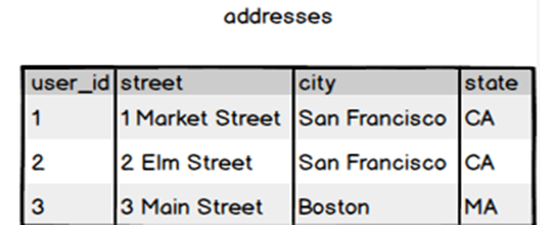

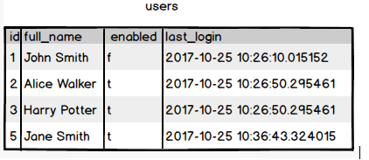

***3.Write a SQL query to fetch all users full_name from San Francisco.***

Select Full_name

From Users

Inner join adresses

On Adresses.user_id=Users.id

Where City=' San Francisco '

***4. Write a SQL query to fetch all users full_name who are not from Main street***

Select Full_name

From Users

Inner Join Adresses

On Adresses.user_id=users.id

Where Street NOT IN ( ‘Main Street’ )

***5. Write a SQL query to fetch user full_name who is equal to user_id from Boston (find user_id value in sub_query)***

Select full_name

From Users

Where ID in

(Select user_id

From Adresses

Where city=' Boston ')